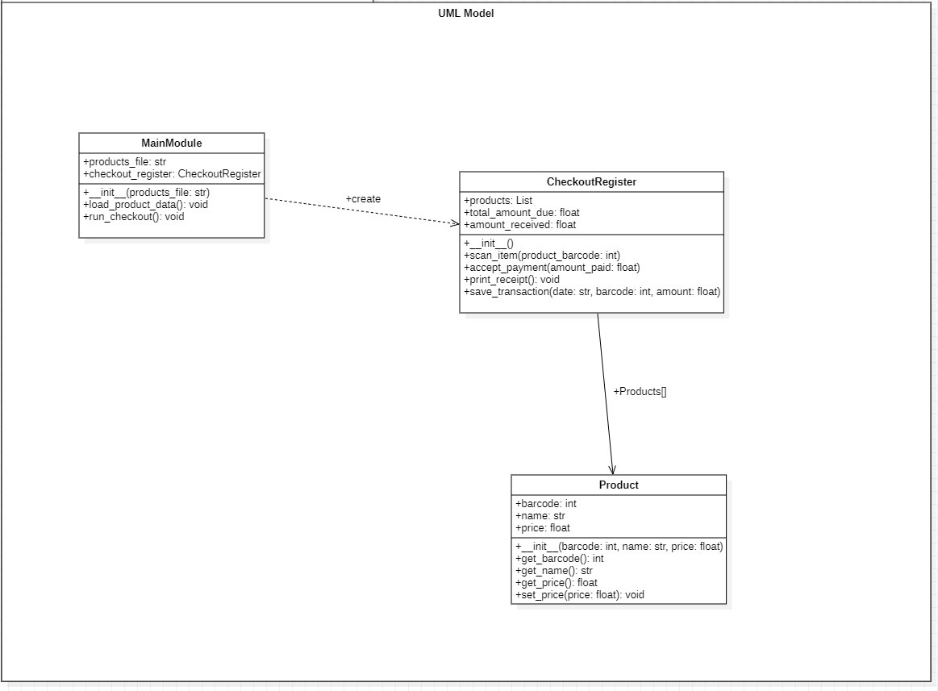

**Test Cases:**

| Barcode | Expected output | Actual output | Comment |
| --- | --- | --- | --- |
| 123 | Product name: Milk, Description: Fresh whole milk, Price: $3.50 | Product name: Milk, Description: Fresh whole milk, Price: $3.50 | get_name() get_description() get_price() |
| 456 | Product name: Bread, Description: Soft white bread, Price: $2.50 | Product name: Bread, Description: Soft white bread, Price: $2.50 | get_name() get_description() get_price() |
| 789 | Product name: Cookies, Description: Chocolate chip cookies, Price: $1.75 | Product name: Cookies, Description: Chocolate chip cookies, Price: $1.75 | get_name() get_description() get_price() |

| Barcode | Expected output | Actual output | Comment |
| --- | --- | --- | --- |
| 123 | The scanned product details are displayed, and the current total is updated correctly. |  | **Testing scan_item()** |
| 123 | If $5.00 was spent the method should return $1.50 the correct balance given (change). |  | **Testing accept_payment()** |
| instance of CheckoutRegister. | The instance is created with initial attributes set to their default values. |  | **Testing __init__()** |

**Test Cases:**

* Test Name: Testing Product Getter Methods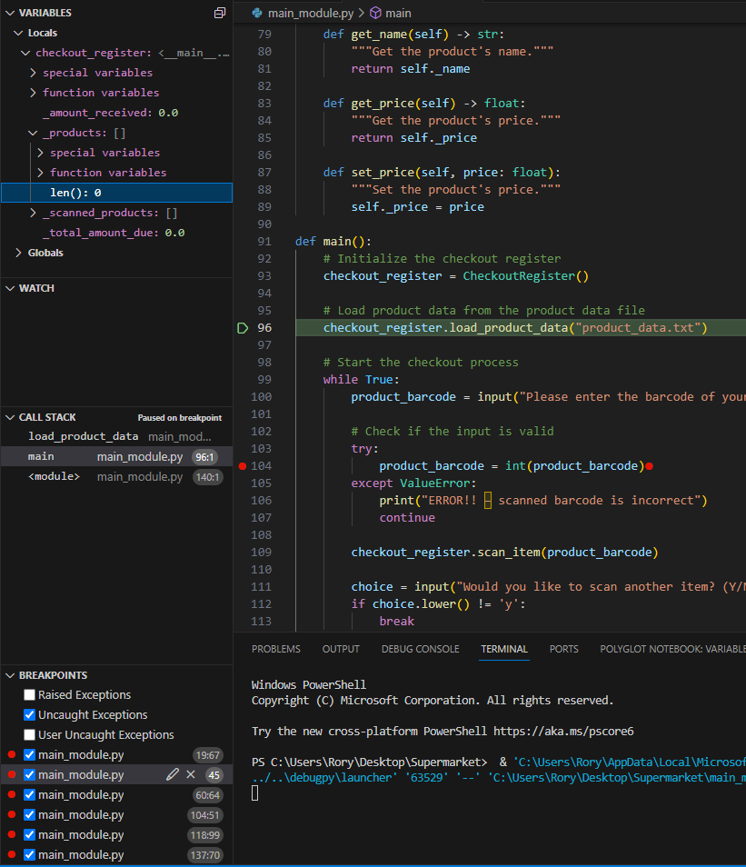
  + Input: Create a product with barcode 123, name "Milk", and price 3.50.
  + Expected Output: product details successfully received.
  + Actual Result:
* Test Name: Checking float variable
  + Input: checkout register total amount
  + Expected Output: Correct calculation of output
  + Actual Result: 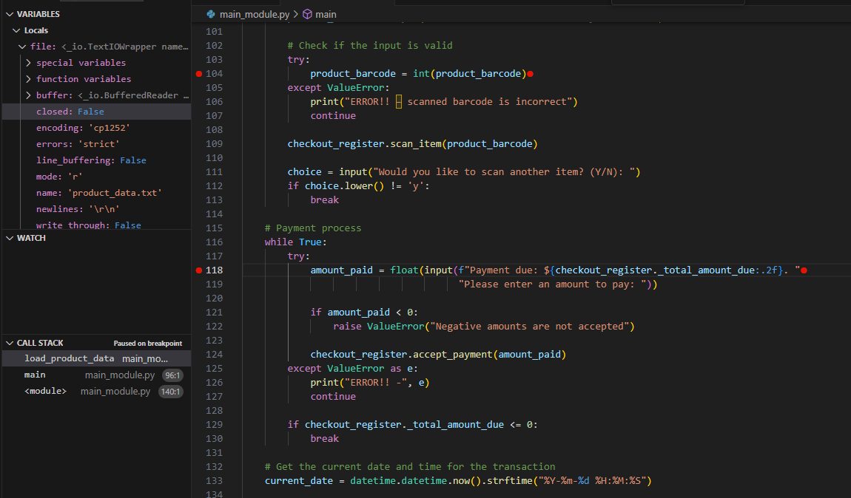

Test Execution:

* Date: 10/09/2023
* Environment: Visual Studio IDE
* Status: All tests recorded as 'Pass'.